CS 105 – Introduction to Computer Concepts
Sample Final – Fall 2011

Name:
UMB ID:
Please show all steps of your work to get full credit
1. True or False? Are the following statements true or false? Please check the appropriate box for each statement.
(a) Phonemes are a set of techniques of using a computer to create the sound of human speech | True [ ] False [ ]
(b) Search engines operate in the following manner: index information, then search and finally crawl the web | True [ ] False [ ]
(c) A biological neuron accepts a single input signal and produces multiple output signals | True [ ] False [ ]
(d) The word ‘hard’ can be ambiguous to a natural language processing system | True [ ] False [ ]
(e) A DoS is an attack on a network resource that prevents authorized users from accessing the system | True [ ] False [ ]
(f) According to Turing test, as long as an interrogator can not distinguish whether the responses are given by human or by a computer system, the computer system is intelligent. | True [ ] False [ ]
(g) AI is only studied by computer scientists. | True [ ] False [ ]
(h) Both XML and HTML are used to display data. | True [ ] False [ ]
(i) HTML tags are defined by Microsoft and used in Internet Explorer. | True [ ] False [ ]
(j) XML uses hierarchy structure to represent data. | True [ ] False [ ]
(k) The tag <li> means link in HTML. | True [ ] False [ ]
(l) You can only use one column as the key of a table in database. | True [ ] False [ ]

2. The following are an information system containing 5 tables. Please answer the questions according to these tables.
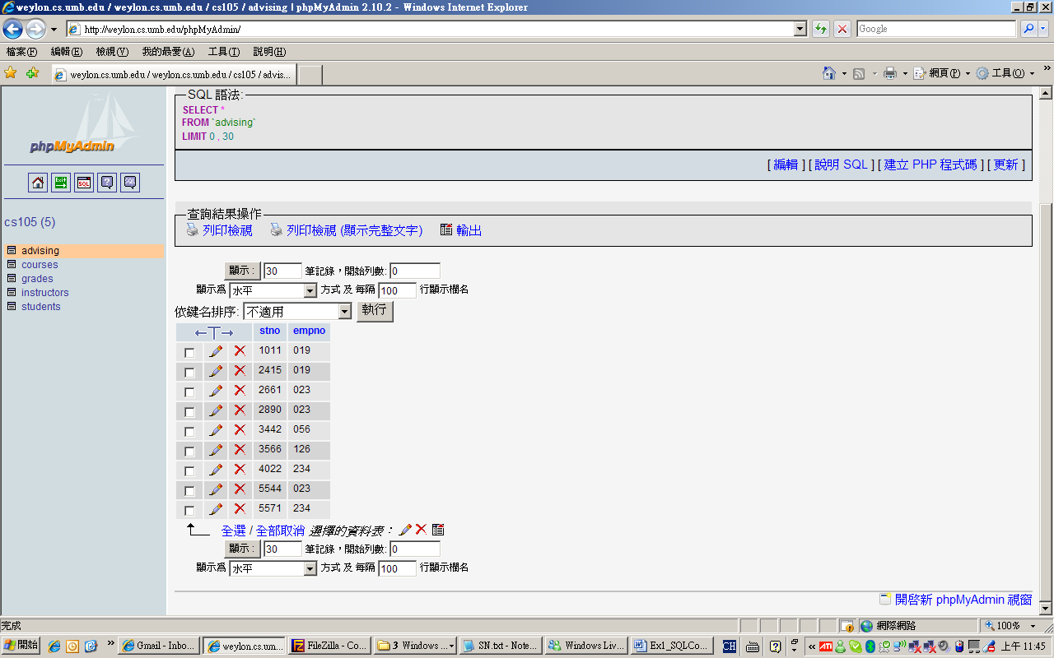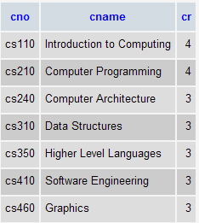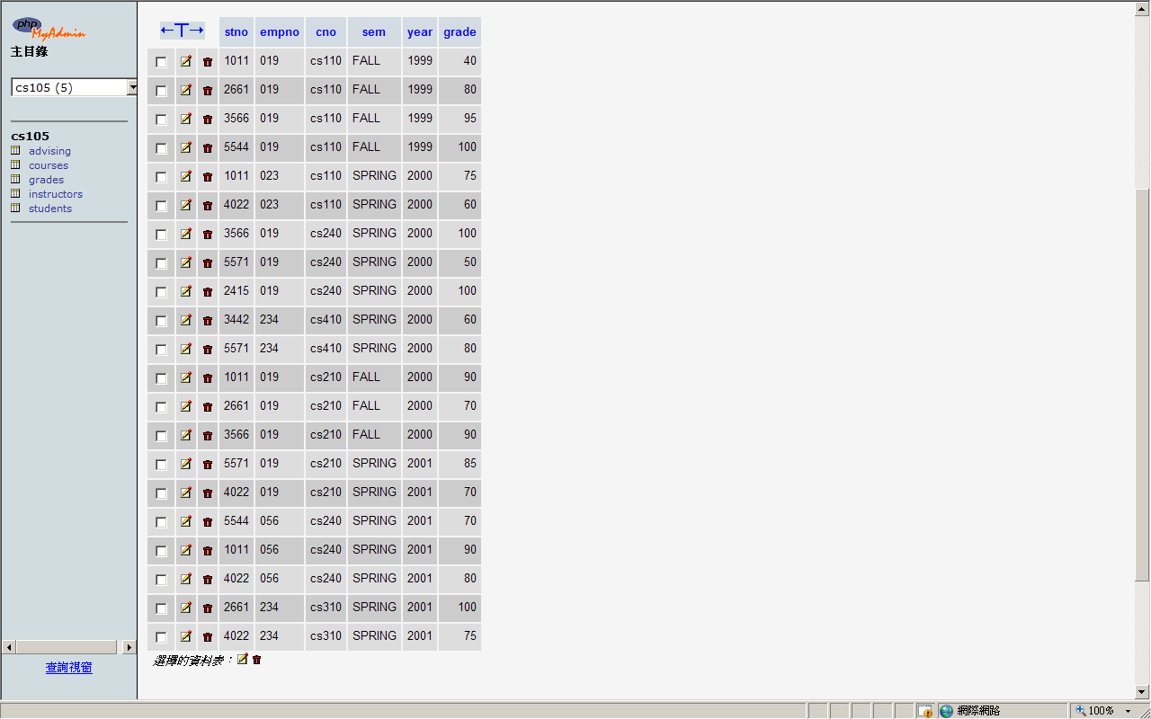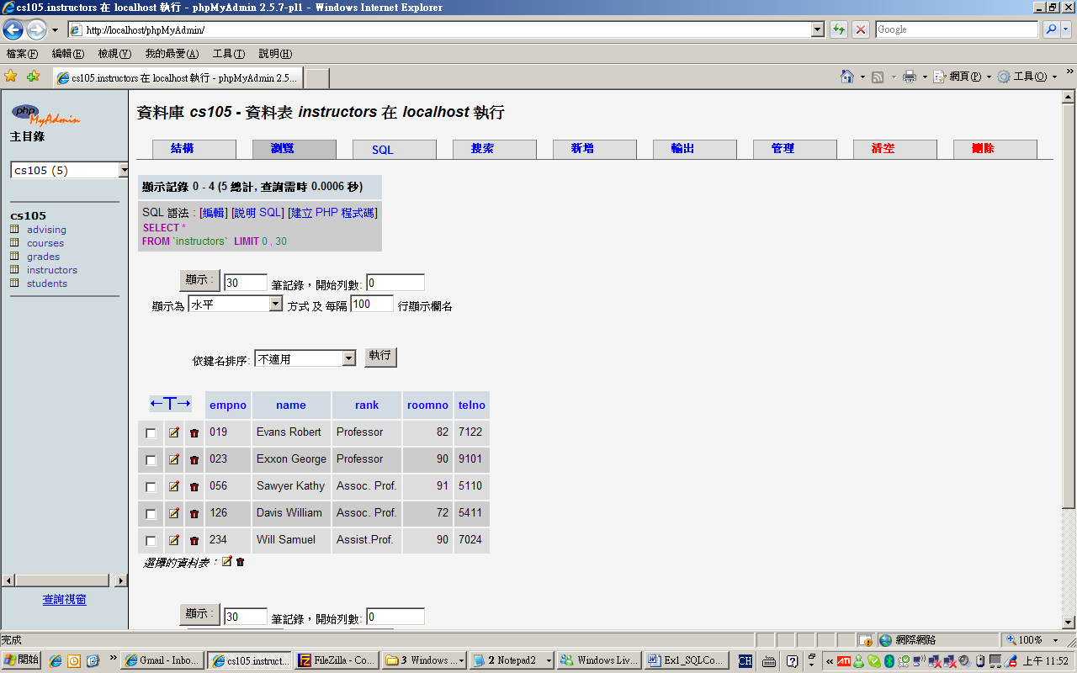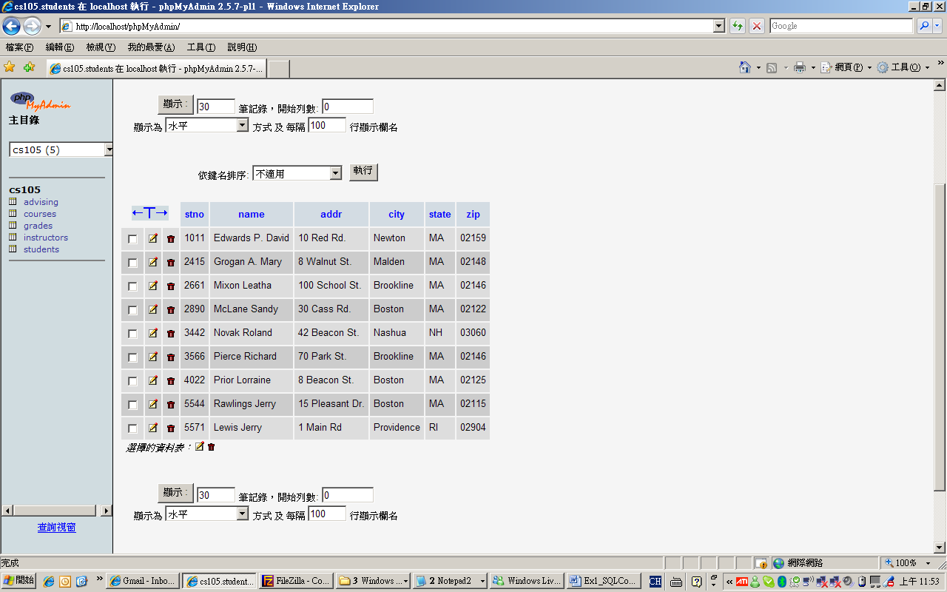
Advising
Courses
Grades
Instructors
Students
- Draw the ER diagram for Tables Students, Instructors, and Advising.

- Is it a good idea to include course name (cname, e.g., introduction to computing) in Grades table? If not, please use an example (or a scenario) to explain why.

- According to these tables, how many credits did Prior Lorraine earn? (Assuming that he can get the credits if his grade is greater or equal to 60.)

- Suppose there are two sections for CS110 or other courses and each section may be instructed by different instructors, how should you modify these tables (or add new tables) to represent this situation? Please draw the updated ER Model. (You only need to draw the updated parts.)

3. Explain how a GPS represents a map using search trees? How a GPS calculate the fastest (shortest) routes.
4. Explain the advantage and disadvantage of cloud storage (such as Dropbox). Discuss the synchronization, security, privacy, and backup issues about cloud storage.

