CS105 Homework Assignment 2 Name:
Due 11:00am, Oct 5, 2011.
You must turn in hardcopy in class. Late homework will NOT be accepted.

1. Convert 711 to binary.

2. Convert 111001 to decimal.

3. Compute 1111 x 1111 (show your steps)

- There is a wave as the following graph, please use 1 bit and 2 bits in each time interval (there are 10 in total) to convert this wave to digital signals. (draw the digital signal in the graph)

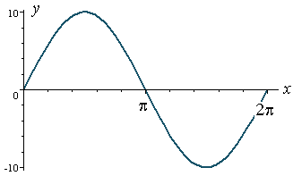
- There is an 8x7 image and the image use 1 bit (either black or white) to represent a pixel. Since multimedia files usually take a lot of storage, we decide to use some lossless compression to reduce the size of this image. (You could use Run-length Encoding and/or other method. If you want to replace some common strings into symbol (Keyword Encoding), you should also explain it.)
