CS105 Homework Assignment 3
Due 11:00 AM, Dec 7 2011.

- Watch the video
http://video.google.com/videoplay?docid=-1508211417393454786#

Write a paragraph (about 200 words) discussing search engine.
Some pointers: (suggested but not limited to:)
- Think about why google (the search engine) is so popular

You could discuss why people need search engine (too much information on internet), the user interface, the results responded by the search engine (accuracy/ match what you want, …)

- What do you think about the work environment at google (the company)?

You might discuss “work hard, play hard” and how you feel or your expection about the company.

- How do search engines work?

See Search Engine slides. You could discuss about Page Ranking as well as crawl/ index/ search.

- Why is natural language comprehension a hard problem for a computer?
See AI Application slides 13-15.
3. Answer the following questions according the tables.
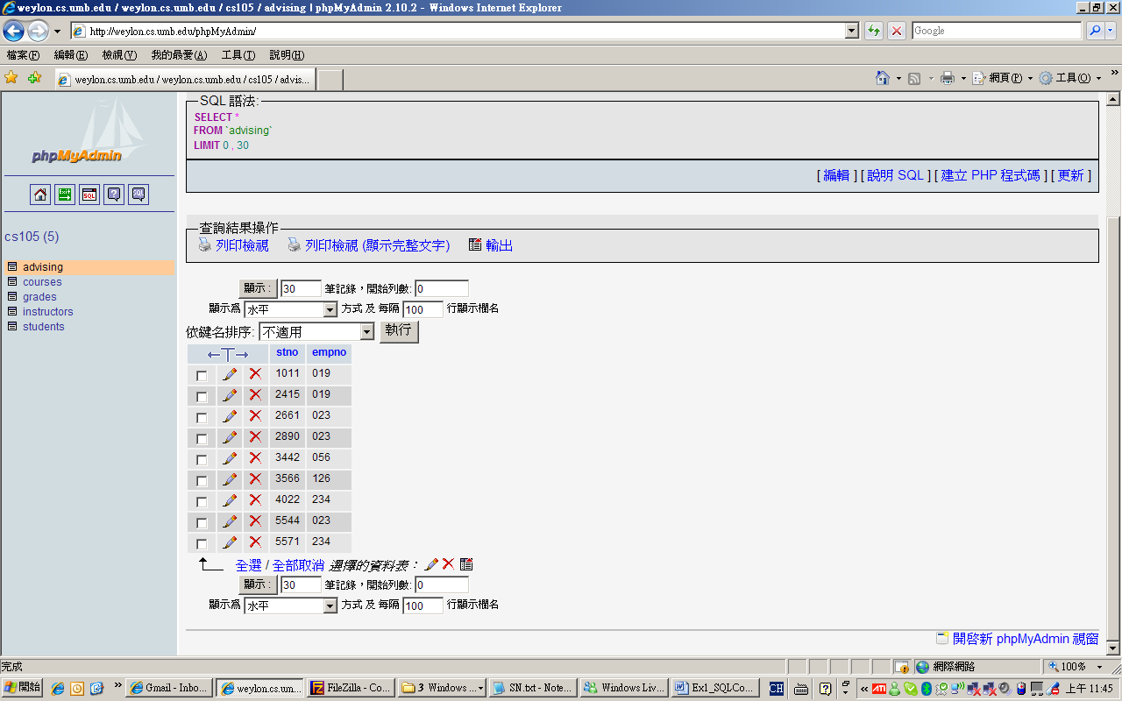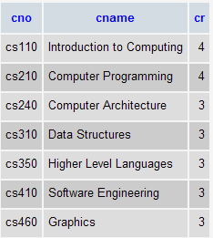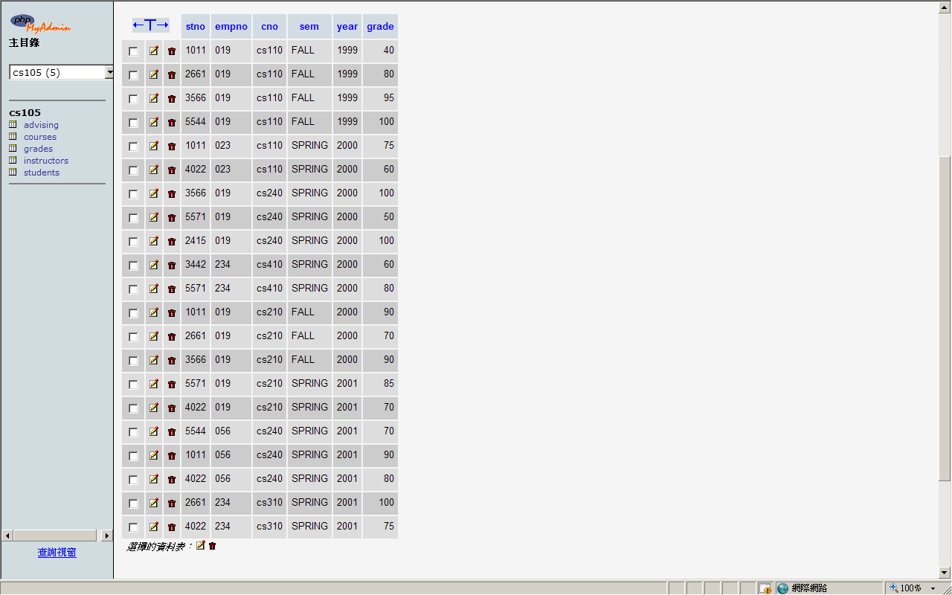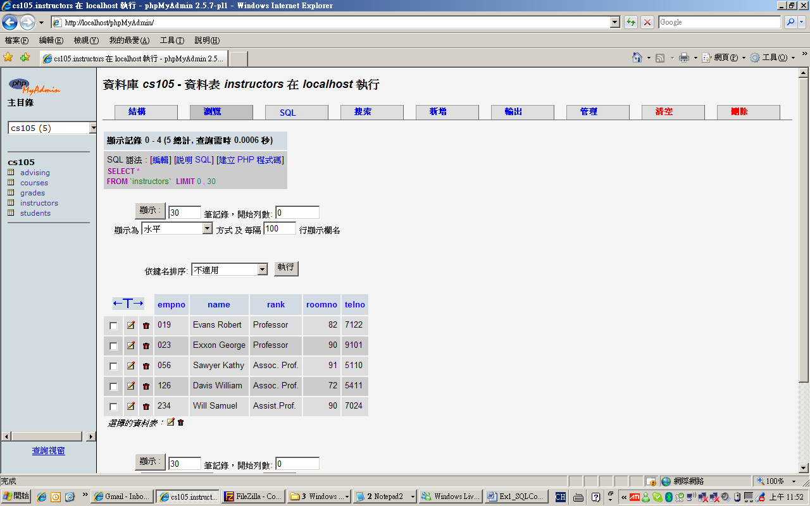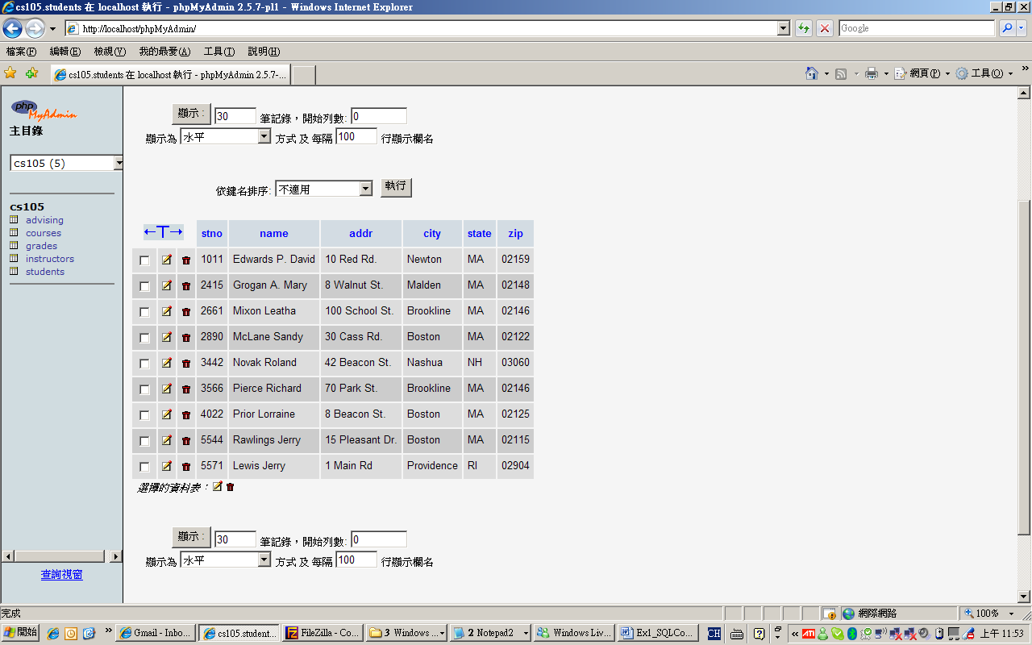
Advising
Courses
Grades
Instructors
Students

3.1 Write down the SQL command to show the names of instructors which are 3 credits.
The question should be “the names of courses which are 3 credits”
Select cname
From Courses
Where cr = 3
3.2 Write down the SQL command to show the names of students who live in Newton or Brookline.
Select name
From Students
Where city = ‘Newton’ or city = ‘Brookline’

3.3 Write down the SQL command to show the names of students whose grades (in at least one course) are greater than 90.

Select Students.name
From Students, Grades
Where grade > 90 and Students.stno = Grades.stno

4. The following is an xml document. Organize the tags and make the xml document a better organized one. (You should correct the xml if it is not well-formed)
Solution:
<?xml version="1.0"?>
<catalog>
<book id="bk101">
<authors>
<author>Gambardella, Matthew</author>
<author>Galos, Mike</author>
</authors>
<title>XML Developer's Guide</title>
<genre>Computer</genre>
<price>44.95</price>
<publish_date>2000-10-01</publish_date>
<description>An in-depth look at creating applications
with XML.</description>
</book>
<book id="bk102">
<author>Ralls, Kim</author>
<title>Midnight Rain</title>
<genre>Fantasy</genre>
<price>5.95</price>
<publish_date>2000-12-16</publish_date>
<description>A former architect battles corporate zombies,
an evil sorceress, and her own childhood to become queen
of the world.</description>
</book>
</catalog>

