CourseDB Exercise Name:
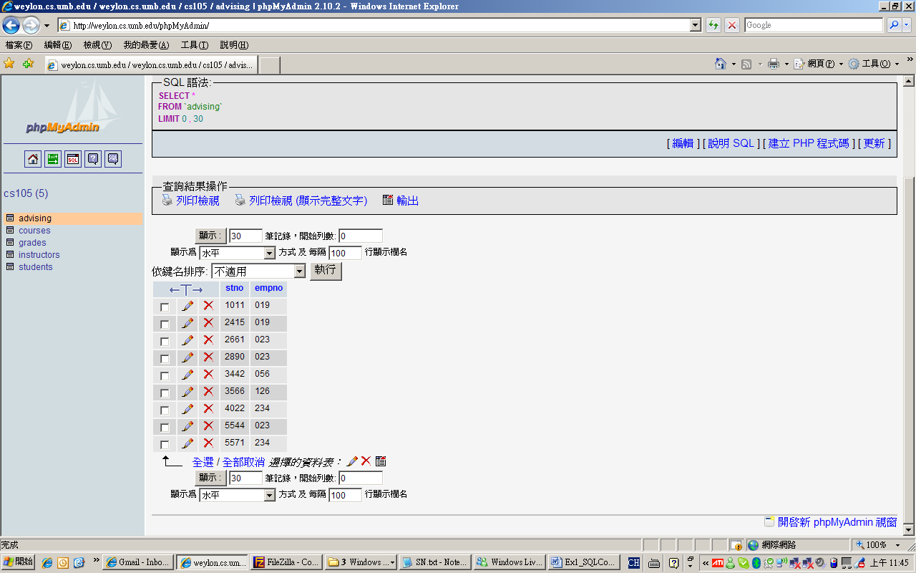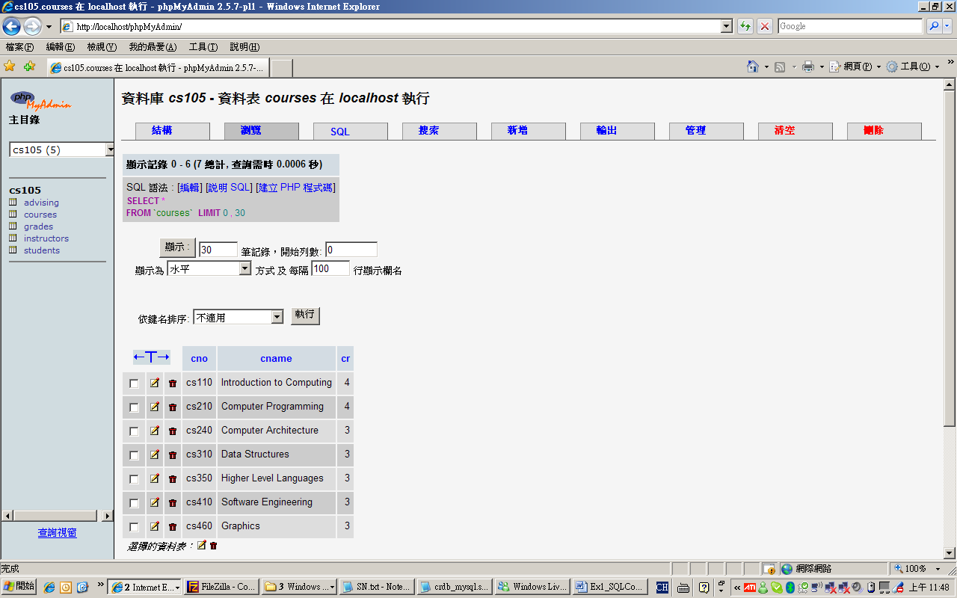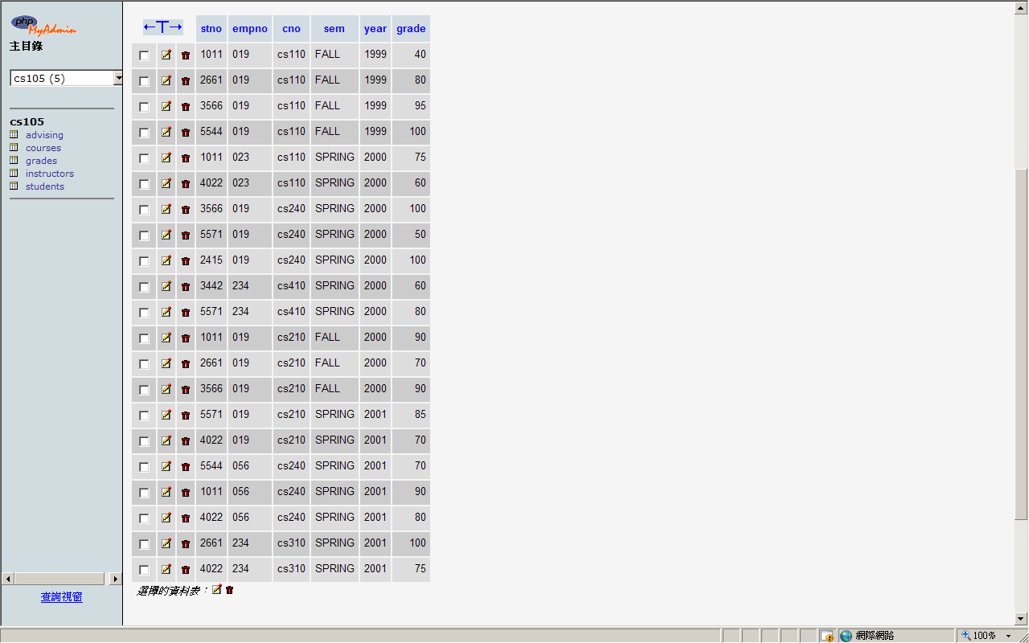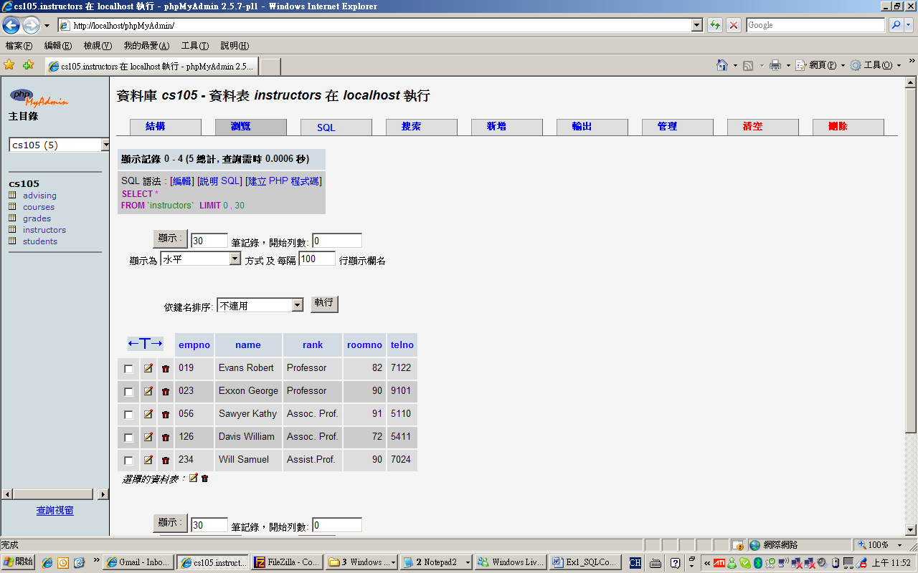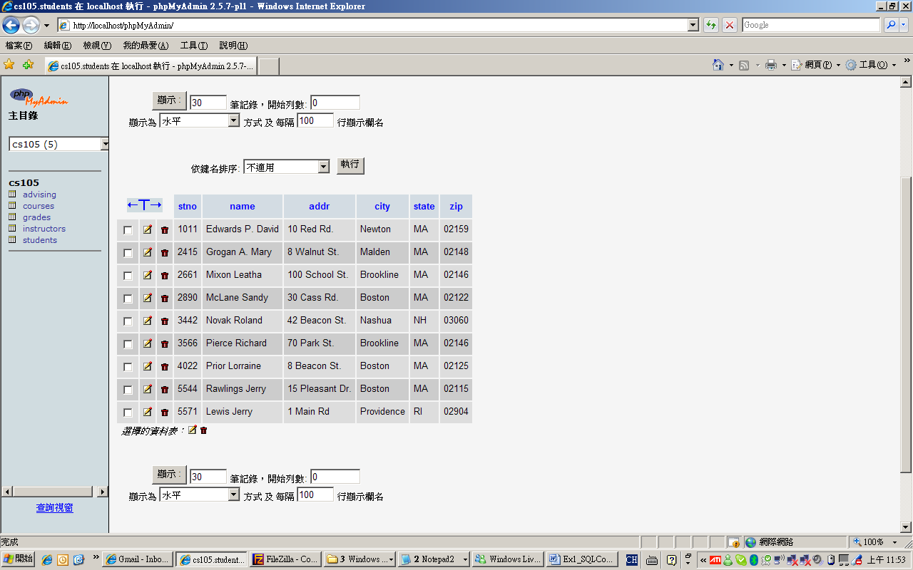
Advising
Courses
Grades
Instructors
Students
- Write down the SQL command and results (as a table) to show the names of students who live in NH or RI.

- Write down the SQL command and results (as a table) to show the names of students whose grades (in at least one course) are grater than or equal to 95.

